Zepr - Zombie Engineering Project
User Manual

Contents

Introduction ..………………………………………………………………………………...01

Main Menu ..…………………………………………………………………………………02

Stage and Character Selection ……………………………………………………………….03

Pause Menu ………………………………………………………………………………….04

Gameplay ……………………………………………………………………………………05

Full list of characters and power ups ...………………………………………………………07

Mini Game …………………………………………………………………………………..10

Introduction

Scenario

After a hard night of partying after the dreaded POPL exam, you wake up to find yourself in the middle of town, your friends nowhere to be found.

As you try and recall how you ended up here, you hear a low rumbling sound coming from the alleyway near you.

A horde of decaying zombies suddenly appears out from the alleyway, their clothes tattered, blood and bone sticking out of their bodies.

Not soon after, the zombies notice you and charge towards you, trampling over each other, their rumbles turning into screams and cries.

But in the spur of the movement, you suddenly realize...

You forgot to hand in your SEPR assessment!

Your goal is to survive and defeat the horde of zombies and get back to your accommodation, to hand in your SEPR assessment before the deadline is over. But do be careful, if the zombies catch you will be ZOMBIFIED!



Main Menu

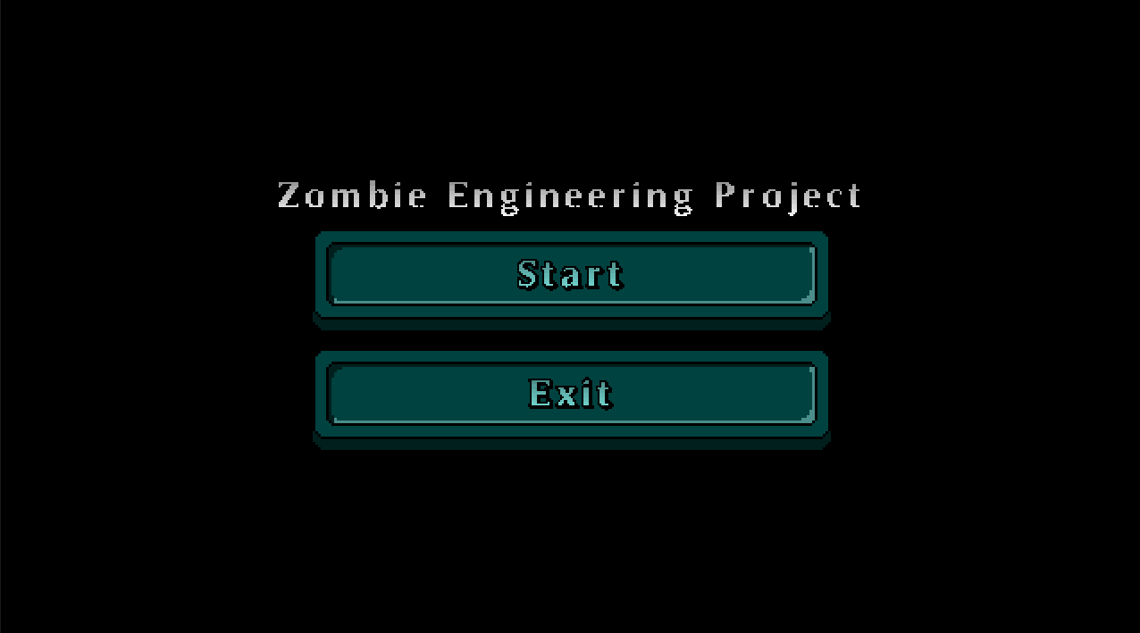

After launching the game, you will be navigated to the main menu.

Click “Start” to begin the game.

Click “Exit” to close the game.

Stage and Character Selection
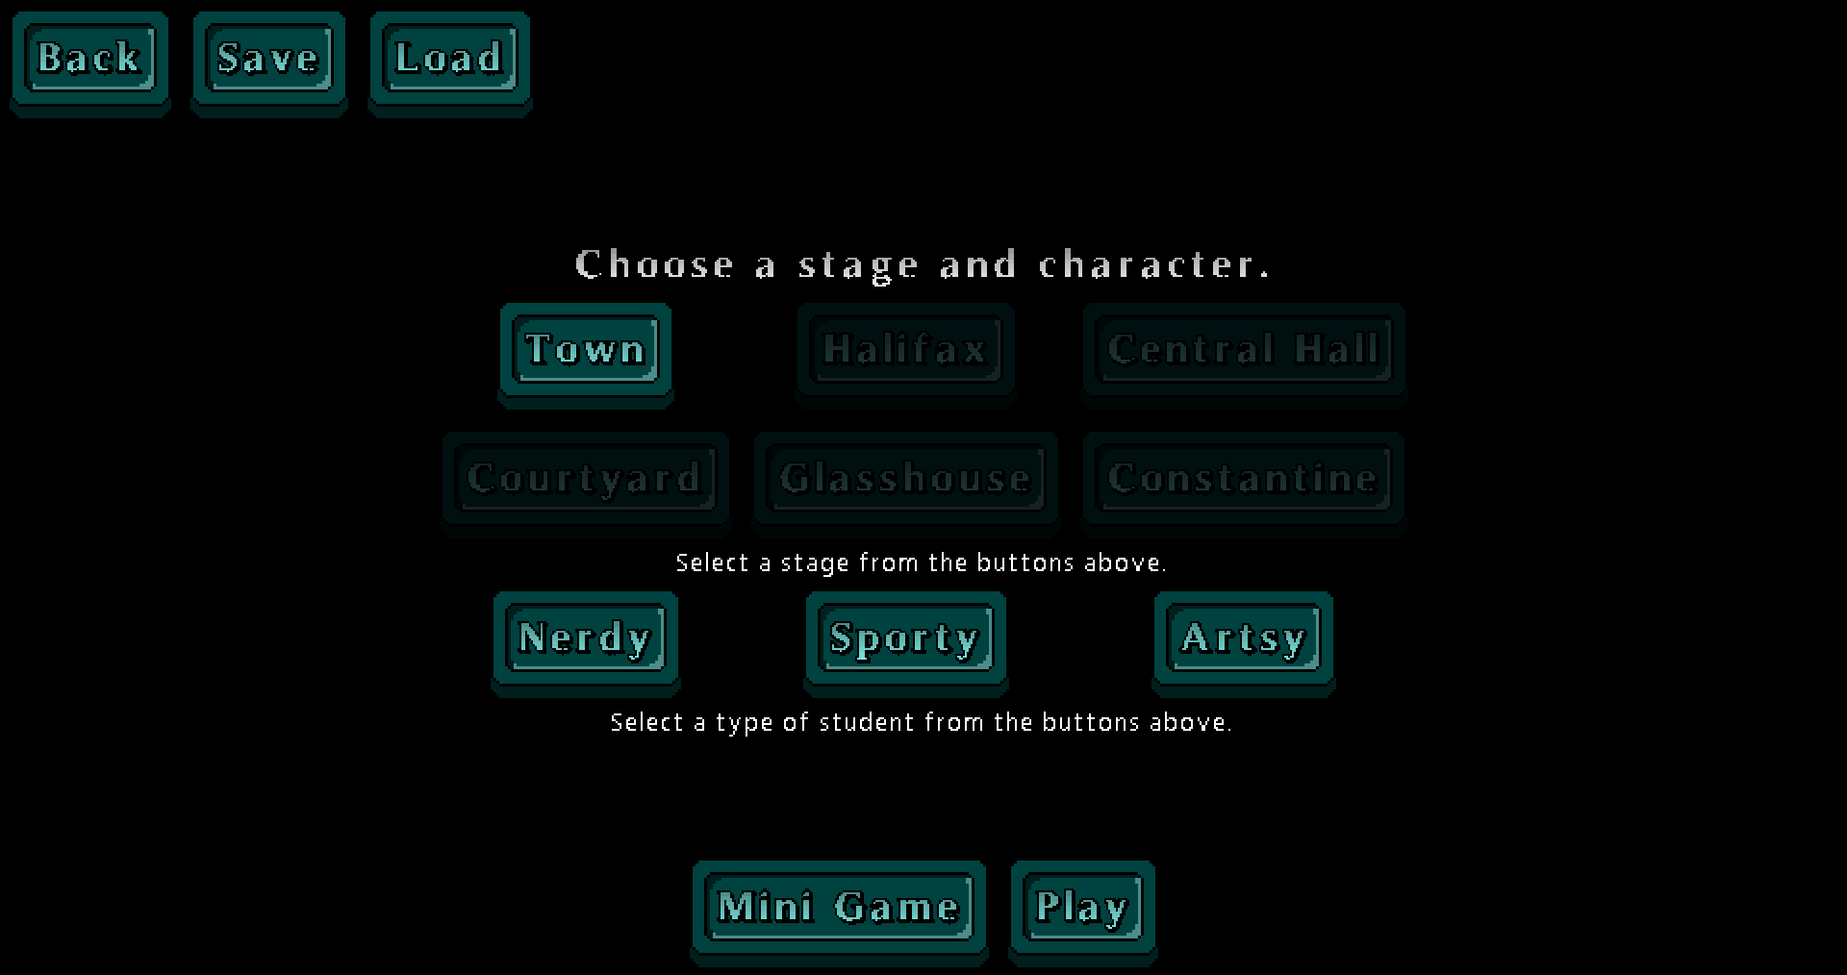

Stage

Stage selection allows you to select which stage you wish to play in, where each stage will offer different obstacles and hence require different strategies to overcome.

Characters

Character selection allows you to play as your choice of character, where each character will offer unique strengths over the other.

Select one of “Nerdy”,“Sporty” or “Artsy”.

Pause Menu

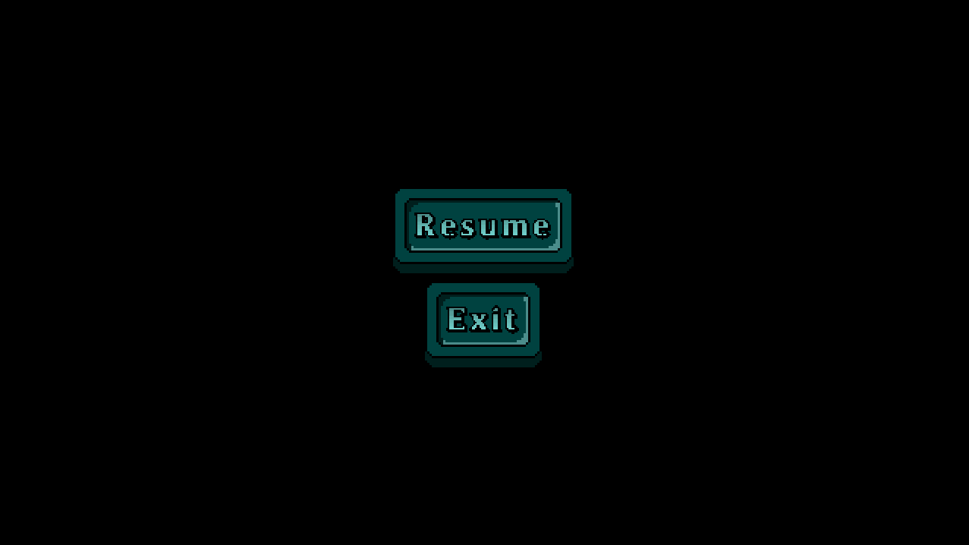

You can pause the game by pressing the “Esc” button.

To return to the game, click the “Resume” button.

To close the game, click the “Exit” button.

Gameplay

Controls

Key | Action
W | Moves the character up the screen
A | Moves the character left on the screen
S | Moves the character right on the screen
D | Moves the character down on the screen
E | Trigger player special ability
LMB (Left Mouse Button) | The character attacks.
Escape | Brings up the Pause Menu

Graphical Interface
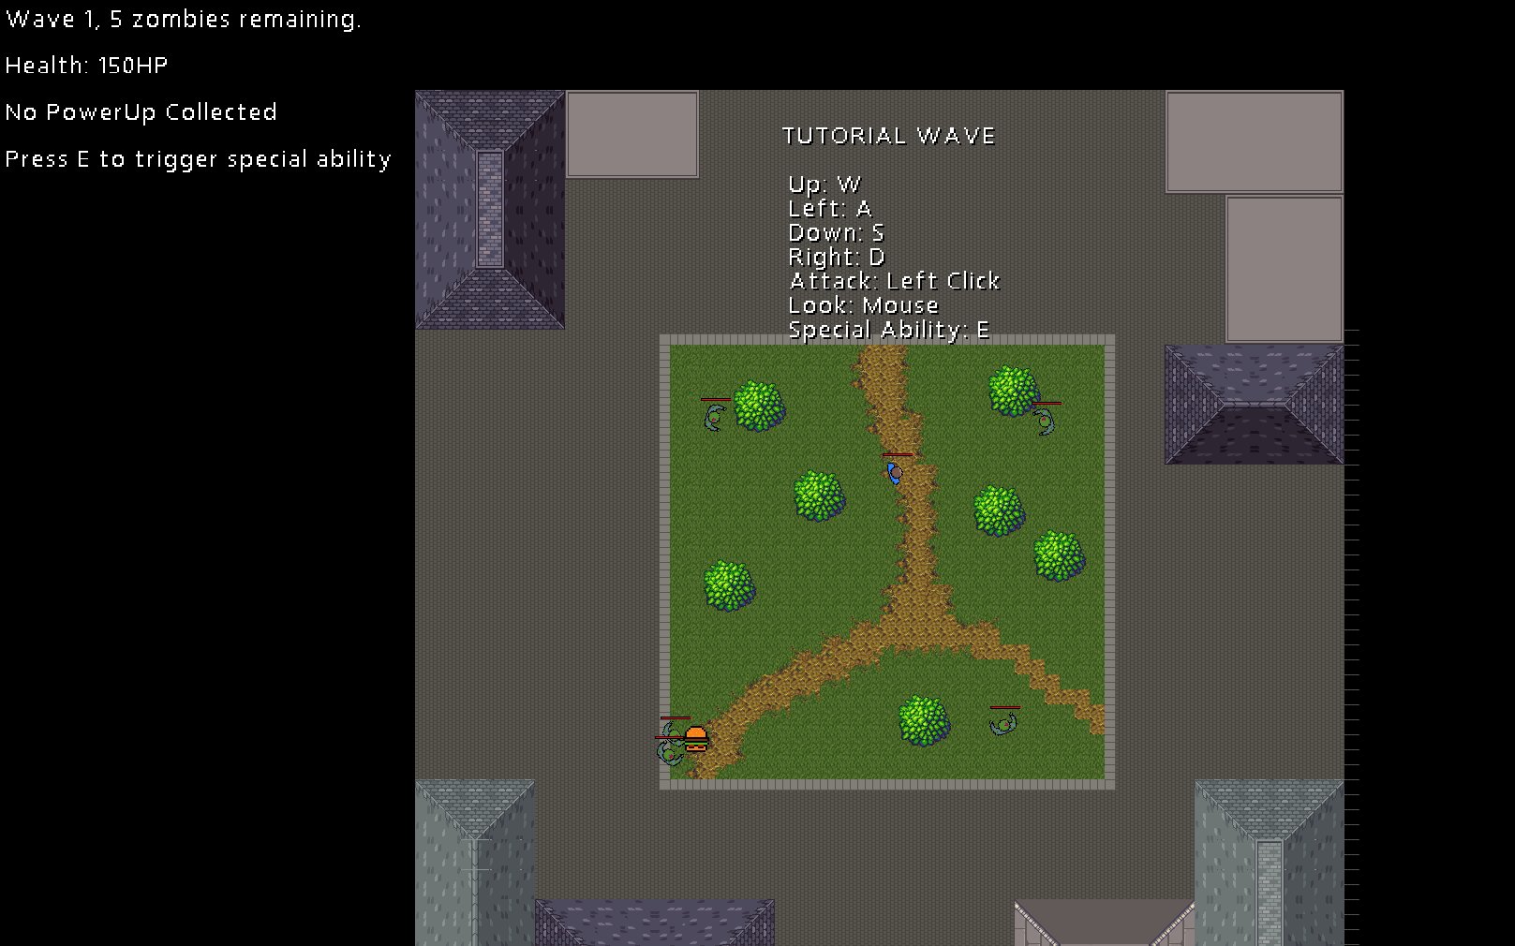

Information on the wave number, the number of zombies remaining in the wave, and the player’s health total is shown on the top left of the screen. The first level starts with a tutorial wave, explaining all necessary controls for playing the game.

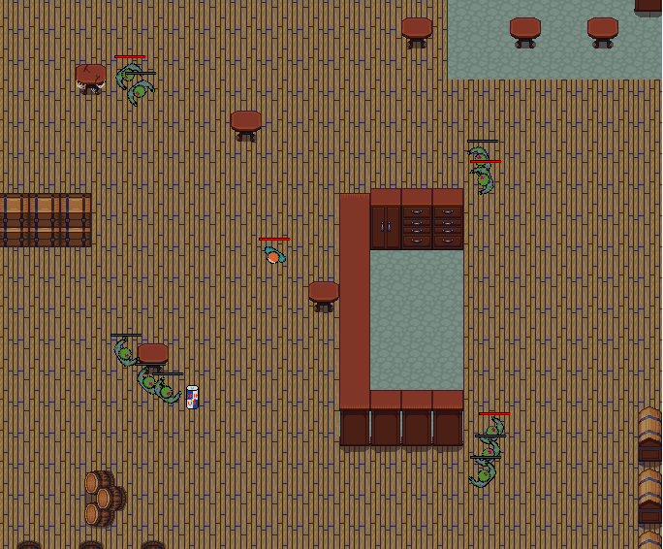

Players must defeat all of the zombies in the wave to progress to the next wave. After completing several waves, the stage is complete, and the next stage is unlocked (if available).

To complete the game, the player must complete all six stages, Town, Halifax, Courtyard, Central Hall, Glasshouse, and Constantine.

However if the player’s health drops down to 0 before completing all three stages, the player will die. The player will be given the option to return back to the level, but on their return they will be a zombie and the objective changed. The now zombified player must chase and attack the humans running away. After the zombified player completes the level they will be returned to the main menu. However, in order to unlock the next level, the player must complete the level as a human.

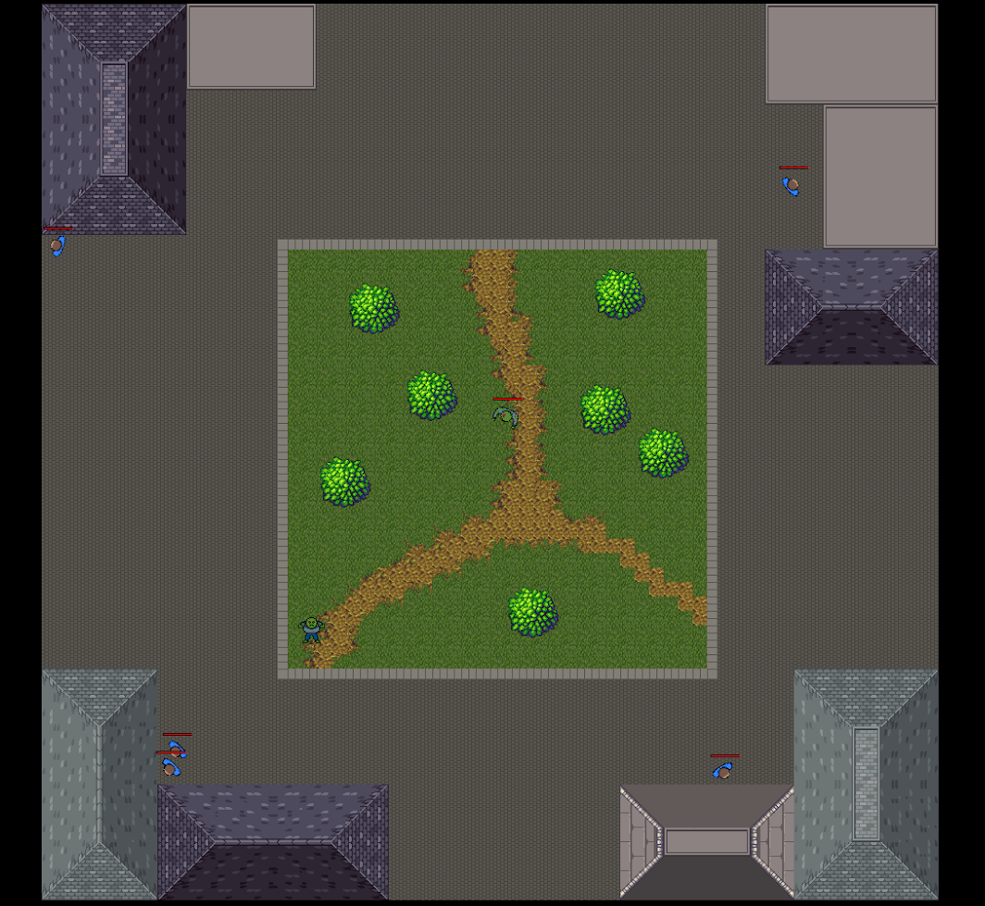

Full list of Characters, Enemies and Power Ups

Playable Characters:

Nerdy

Has higher health. Equipped with a calculator, which is useless at a weapon but better than nothing, giving a low attack damage value.
Special Ability: Temporary strength boost

Sporty


Has greater mobility. Equipped with a baseball bat weapon which gives a minor attack damage value.
Special Ability: Temporary speed boost

Artsy

Deals more damage. Is equipped with a paint brush which is an effective weapon with powerful ‘creative juices’ which give a high attack damage value.
Special Ability: Temporary damage boost

Power Ups:

Heal


Heals the player up to 30 hp.

Speed up

For the next 10 seconds, increases the movement speed of the player.

Immunity

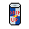
For the next 5 seconds, makes the player immune to zombie attacks.

Insta-Kill


For the next 5 seconds, all zombies are killed with one shot, and damage to bosses is greatly increased.

Invisibility


For the next 5 seconds, makes the player invisible to zombies.

Cure

Turns nearby zombies into human characters

Enemy Characters:

Football Society

Well balanced, not particularly strong but can spawn in high numbers

Hacking Society

Deals a high attack damage

Art Society

Deals a very high attack damage and moves quickly

Environmental Society
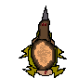
Has a high health value

Star Trek Society
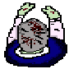
Has a very high health value
Can teleport nearer to the player, and respawn itself

Human
When player is a zombie the human character runs from the player and does not do damage on the player.

Zombie Player

Mini Game:

The objective of the mini game is to survive as long as possible while zombie after zombie comes out and tries to eat your brains! Each kill adds to your tally. Try to get as many kills as you can before the zombies get to you.

